
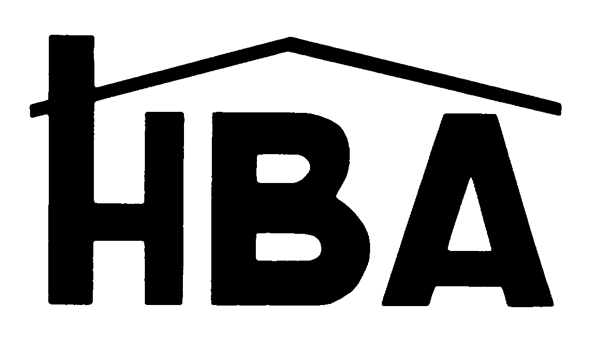
BUILDER CONTRACT

HOME BUILDERS ASSOCIATION OF METRO MOBILE
2015 PARADE OF HOMES BUILDER/DEVELOPER CONTRACT


This agreement is an application by the undersigned (a full builder or developer member of the HBAMM) to build a Home or provide a Village for the 2015 Parade of Homes, October 17th, 18th, 24th & 25th. In consideration of the Home Builders Association of Metro Mobile (HBAMM) providing services in conjunction with the Parade of Homes, the applicant agrees and is bound by all the rules and regulations contained in the Builder Packet. Please sign below and attach payment.

I am a Full Builder member and agree to cooperate with the HBAMM and the Parade of Homes Committee to adhere to the rules, guidelines, and regulations adopted for the successful promotion of the 2015 Parade of Homes.

Full Builder / Developer Signature _______________________________________________________

Company Name & Address _____________________________________________________________

______________________________________________ _____________________________________
Approved by Robert Mullen, Parade of Homes Chairman Approved by Paul Hildesheim, HBAMM President

Complete, sign, then mail to:
Home Builders Association of Metro Mobile
1613 University Blvd., South ♦ Mobile, Alabama 36609

A. Fees & Requirements
Early Bird Entry Fee: Due May 30, 2015 Regular Entry Fee: Due June 30th, 2015
❑ 1st Home - $1,100  1st Home - $1,300
❑ 2nd Home - $850  2nd Home - $1000
❑ 3rd Home - $600  3rd Home - $700
Previous Parade Homes
No fee required for registration, but all rules apply. Must be registered before June 30th, 2015. Model Homes Excluded.
BUILDERS’ & REMODELERS’ PARADE ENTRY FEES – Non-Refundable

Entries Received after June 30th Must be Approved by the Parade Chairman and Executive Officer
Regular Entry Fees Apply. Builder will not be featured in the Plan Book with a full page. Rather, there will be a single page listing all last minute entries (Builder information, subdivision, address, etc.) There will be no color rendering or floor plan of last minutes entries in the Plan Book. Last minutes entries will not be included on the Parade Map. The HBAMM does not guarantee that Last Minute entries will be included in any advertising.

NEW & REMODELED PARADE HOMES

 |  | SQ. FOOTAGE  (Heated/Cooled) |  | SUBDIVISION |  | LOT # |  | STREET ADDRESS |  | AMOUNT DUE
1
2
VILLAGE FEES

Entry Fee: $2,000 (a minimum of three entries required) Fee Due: June 30th

Village Name ______________________________ Lot Nos.___________________ No. houses in village__________________
*Villages are subdivisions with three or more entries built by one or more builders.
Benefit: Villages are “pushed” to the front of the Plan Book directly behind the Showcase subdivision. Otherwise subdivisions are placed in alphabetical order following the Showcase subdivision.
FOR CREDIT CARD PAYMENTS
Visa/MC #: Exp. Date: Amount:

Signature: Name as appears on card: ____________________________________

B. Builder Responsibilities
- Provide the HBA with a reduced copy of correct floor plans (required) and correct front elevation (required) - 8 ½ x 11”. Please note exterior colors (roof, brick, trim, stucco, etc.) for rendering. Due June 30th
- Provide a 5"x 7" black and white or color photo of primary builder. Due July 7th
- Provide a complete house description. Due July 7th
- Provide builder biography. Due July 7thth
- Provide the signed contract with payment attached. June 30th
- Provide signed Hold Harmless Agreement. Due October 3rd
- Provide a certificate of insurance for General Liability insurance not less than 1million dollars naming the HBA of Metro Mobile as additionally insured.
- Provide a Certificate of Occupancy no later than October 9th
- Pick up signs and Plan Books no later than October 12th (providing all inspections are passed)
- Staff your home and have them open from 10:00 – 5:00 each day of the event
- Use only the official yard sign in the front yard of your Parade Home. All other signs must be inside. Exception being large, permanent “Model” home signs.
- Return all sign posts to the HBA office no later than October 30st. A $250 fee will be charged for non-returned signs.

C. HBA Responsibilities
Home Builders Association of Metro Mobile will furnish official Parade signs, pennants, directional arrows and other materials for Parade. HBAMM will promote the event to the consumer as funds allow.

D. Eligibility for Participation

1. Full Builder Member in good standing with the HBAMM.

E. Inspections

1. July 29th - 40% Completed. Failure results in Builders ½ Page Ad in the Plan Book.

Builder may appeal and be re-inspected on August 5th.

2. August 19th - 60% Completed. Failure results in “Under Construction – Not Open” notice on all media.

3. October 7th - Completed House Inspection.

4. October 14th - Completed House Re-Inspection. Failure to pass results in home not being allowed to be open until it passes.
Builder Initial here: _________

F. Rules
1. "For Sale" or unoccupied contract homes only. Exception being “Model” homes.
2. Parade Builders agree that only registered Parade Homes are to be available for showing or open for viewing during the days of the Parade of Homes event.
3. The builder has received, acknowledges and agrees to abide by the Parade Packet which includes the Contract, Inspection Process, Inspection Forms, Checklist, Hold Harmless Agreement, Builder Calendar, and How to Build a Parade Home.
Builder Initial here: _________

G. Parade Event

1. October 17, 18, 24, & 25, 2015 from 10:00 a.m. to 5:00 p.m.
HBA OFFICE USE ONLY:
Date Received: __________________
Check No._____________________
Amount: $____________________

