Mental Health vs Mental Illness

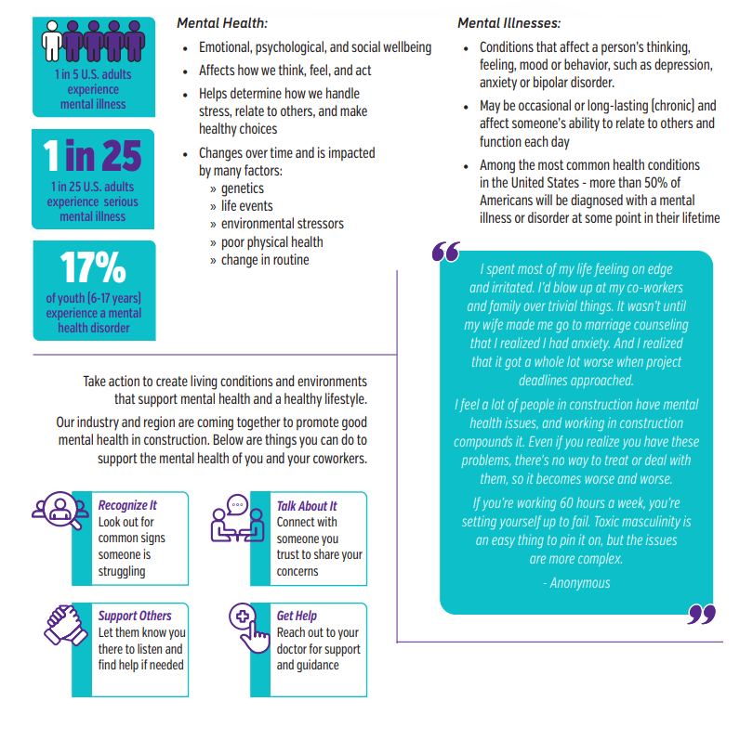

Meeting Leader

NOTE: Always promote a discussion on any of the topics covered in the Tool Box Talks. Should any questions arise that you cannot answer, don’t hesitate to contact any member of the National Mental Health Team.

Reducing Stigma

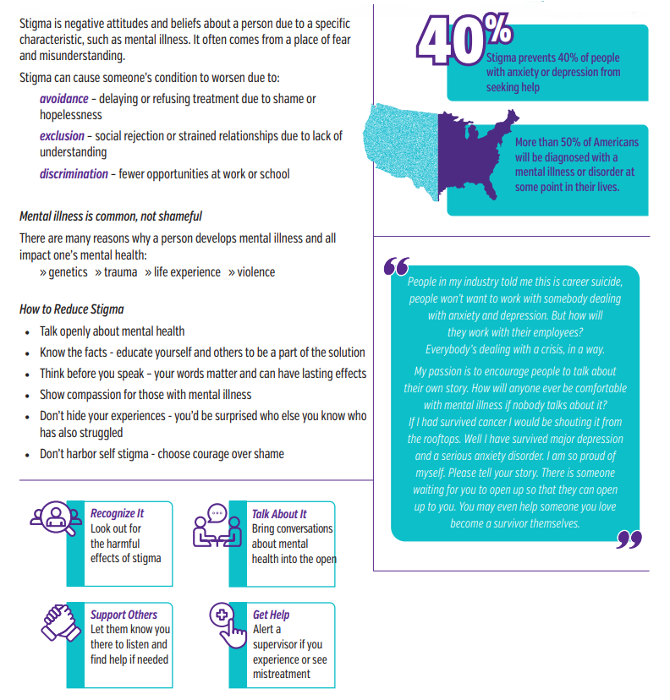

Meeting Leader

NOTE: Always promote a discussion on any of the topics covered in the Tool Box Talks. Should any questions arise that you cannot answer, don’t hesitate to contact any member of the National Mental Health Team.

Stress

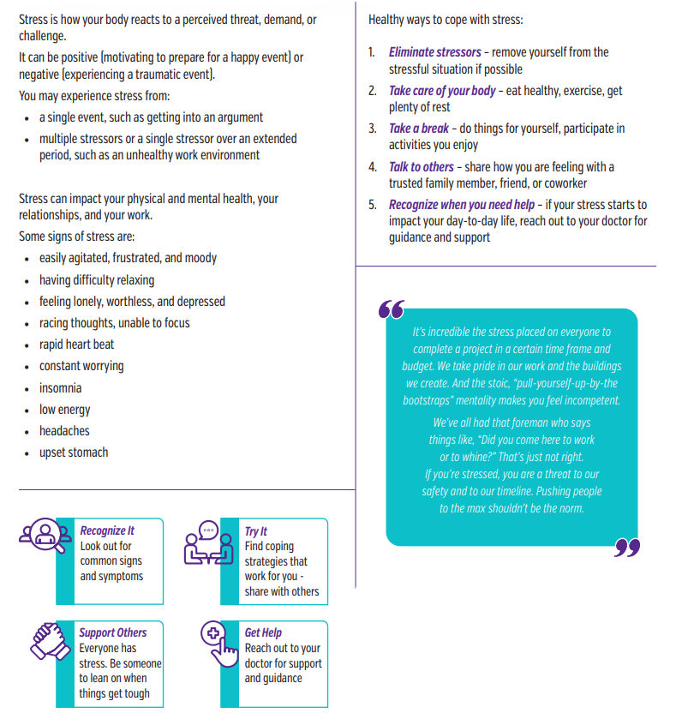
Meeting Leader

NOTE: Always promote a discussion on any of the topics covered in the Tool Box Talks. Should any questions arise that you cannot answer, don’t hesitate to contact any member of the National Mental Health Team.

Depression vs. Anxiety

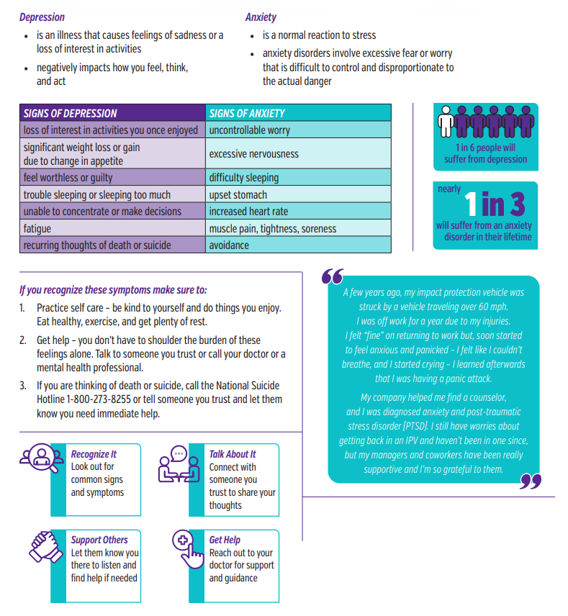
Meeting Leader

NOTE: Always promote a discussion on any of the topics covered in the Tool Box Talks. Should any questions arise that you cannot answer, don’t hesitate to contact any member of the National Mental Health Team.

Self-Care: More Than a Fad

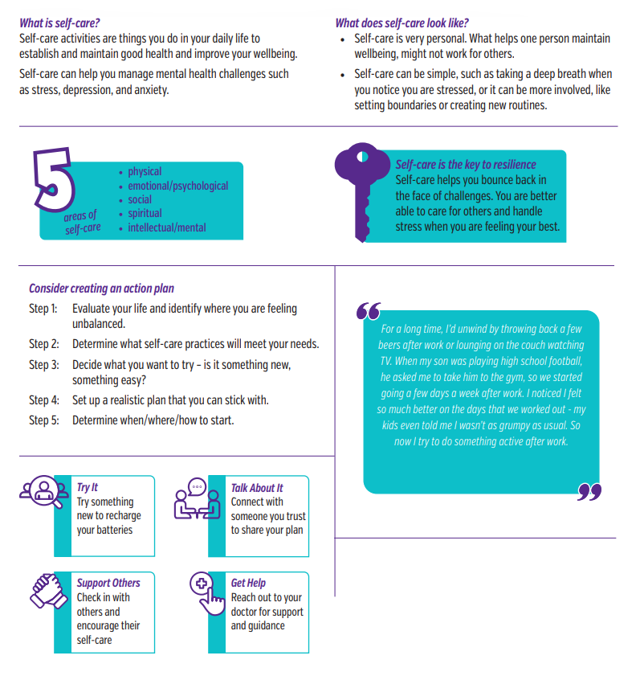
Meeting Leader

NOTE: Always promote a discussion on any of the topics covered in the Tool Box Talks. Should any questions arise that you cannot answer, don’t hesitate to contact any member of the National Mental Health Team.

Awareness of Your Own Mental Health

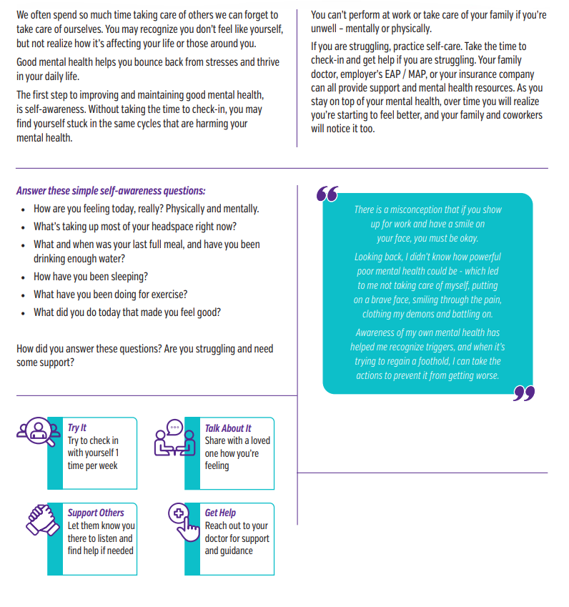
Meeting Leader

NOTE: Always promote a discussion on any of the topics covered in the Tool Box Talks. Should any questions arise that you cannot answer, don’t hesitate to contact any member of the National Mental Health Team.

How to Get Help

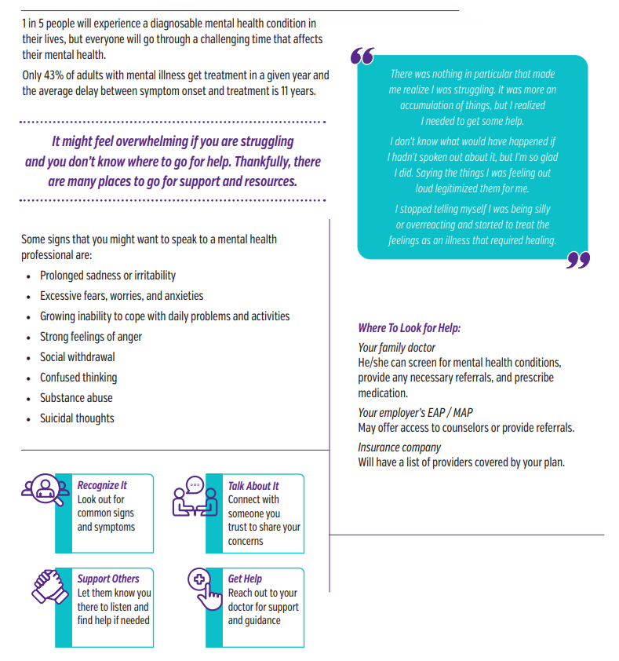

Meeting Leader

NOTE: Always promote a discussion on any of the topics covered in the Tool Box Talks. Should any questions arise that you cannot answer, don’t hesitate to contact any member of the National Mental Health Team.

Suicide Awareness

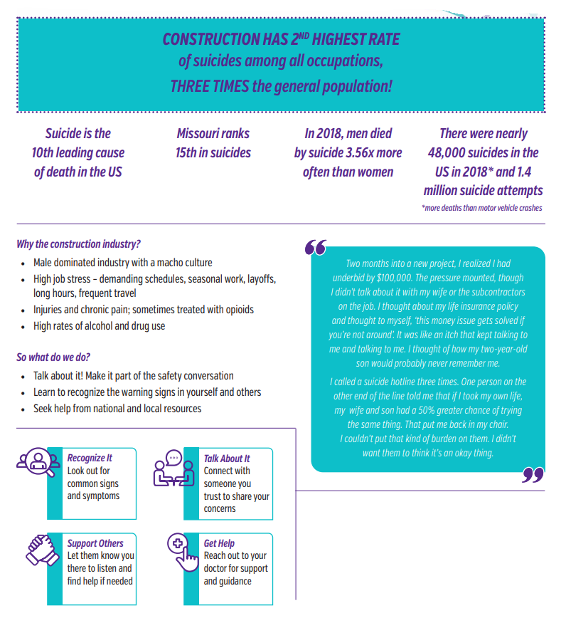
Meeting Leader

NOTE: Always promote a discussion on any of the topics covered in the Tool Box Talks. Should any questions arise that you cannot answer, don’t hesitate to contact any member of the National Mental Health Team.

Alcohol & Drug Use

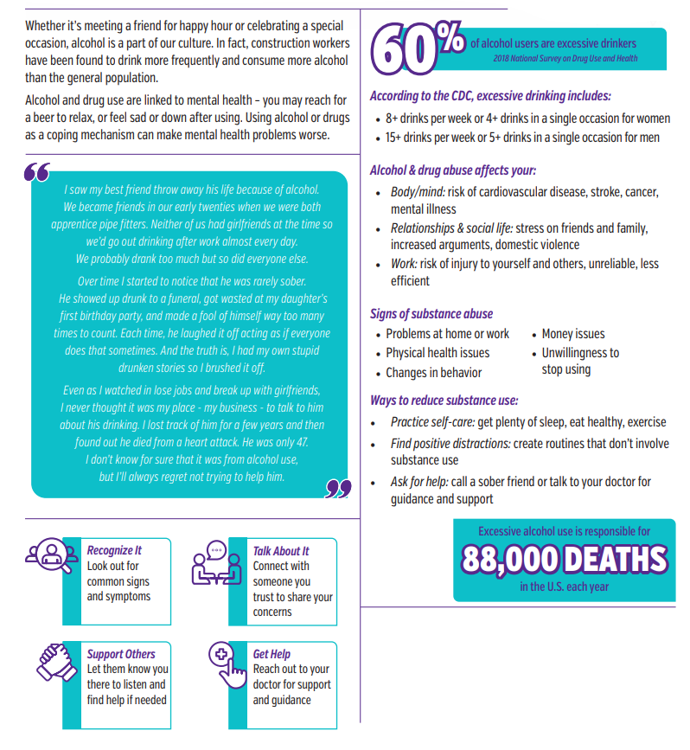
Meeting Leader

NOTE: Always promote a discussion on any of the topics covered in the Tool Box Talks. Should any questions arise that you cannot answer, don’t hesitate to contact any member of the National Mental Health Team.

Opioids & Other Pain Killers

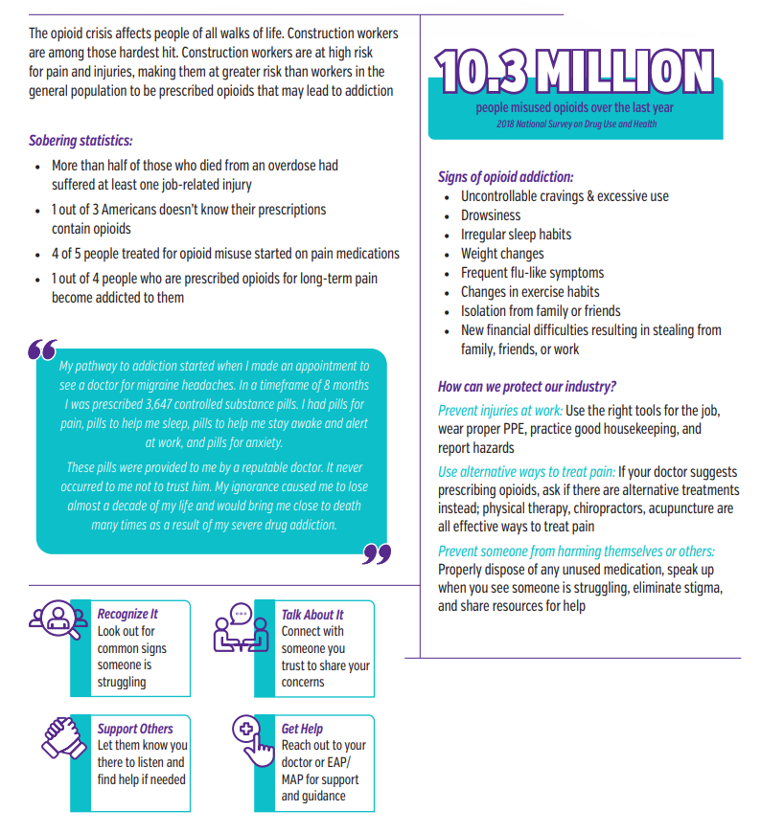
Meeting Leader

NOTE: Always promote a discussion on any of the topics covered in the Tool Box Talks. Should any questions arise that you cannot answer, don’t hesitate to contact any member of the National Mental Health Team.

Feeling Fatigued

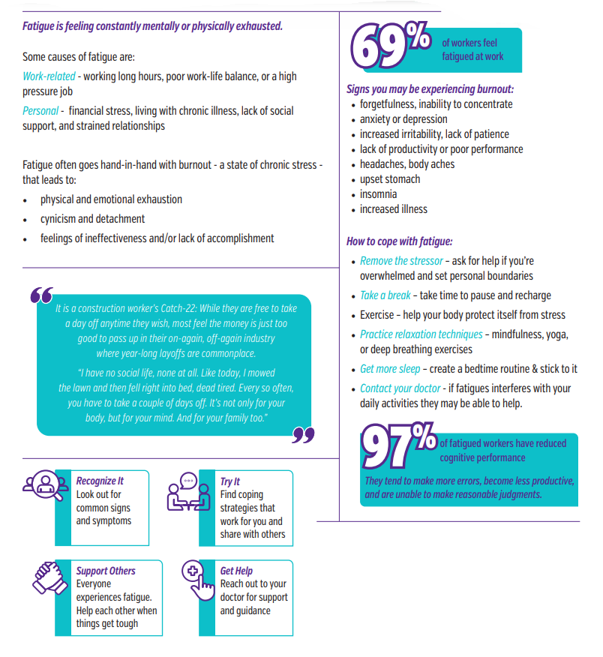
Meeting Leader

NOTE: Always promote a discussion on any of the topics covered in the Tool Box Talks. Should any questions arise that you cannot answer, don’t hesitate to contact any member of the National Mental Health Team.

Bullying – Beyond the Schoolyard

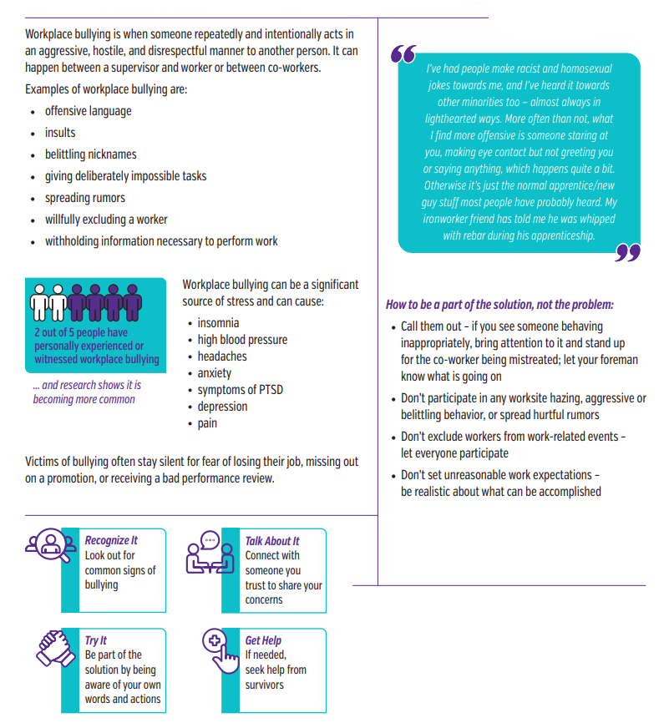
Meeting Leader

NOTE: Always promote a discussion on any of the topics covered in the Tool Box Talks. Should any questions arise that you cannot answer, don’t hesitate to contact any member of the National Mental Health Team.

